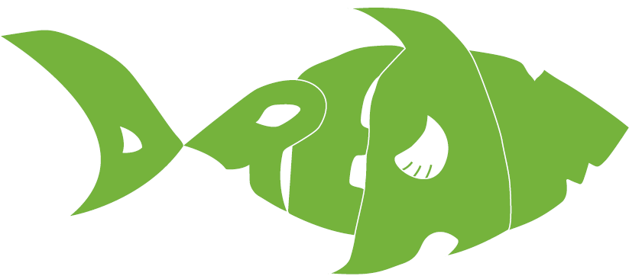
Dominican Republic Emergency Aid Mission
Are You Ready to Make a Difference?
Help us set the table this Thanksgiving with
RICE & DRY BEANS
www.allabouttheDREAM.org

